New Horizons College, Minna

End of 2nd Term Newsletter

Saturday 9th April, 2022 (8th Ramadan, 1443AH)

***If you defend your children’s mistakes one day you’ll hire a lawyer to defend their crime. Discipline is not child abuse. - Anonymous***

***“The best gifts to children from their parents is proper upbringing” (Tirmizi)***

Assalamu Alaykum Wa Rahmatul-lah Wa Barakatuh.

Dear parents,

The best of praises is most befitting to Allah for sparing our lives to witness yet another Holy month of Ramadan. I testify that there is none worthy of worship but Allah, and Allah is the Greatest. He is Allah, other than whom there is no deity; the Sovereign, the Pure, the Perfect, the Bestower of Faith, the Overseer, the Exalted in Might, the Compeller, the Superior.

We truly are living in trying and difficult times, hence the need for us to continue to collectively seek Allah’s intervention through prayers and righteous action. May Allah bring these challenges to an end, amin.

This report will in sha Allah shed light on the activities and events for this term.

**Below are the highlights of this report:**

1. Abridged Calendar for 3rd Term, 2021/2022 session
2. Academic Activities
3. Co-curricular Activities
4. Islamiyyah Report
5. GCE 2022 Result
6. PTA Security levy
7. Ban on Visiting Day items entering the hostel
8. Checking 2nd term Result and Behavioural Reports Online
9. Resumption Date/Time for 3rd term, 2021/2022 Session.
10. **Abridged Calendar For 3rd term, 2021/2022 Session**

Saturday 7th May 2022 - Resumption of Boarders for 3rd term

Monday 9th May 2022 - Day Students Resume

Saturday 11th June 2022 - PTA General Meeting / Visiting Day

Thursday 16th June 2022 - Centralized Test Begins

Saturday 2nd July 2022 - Online Open Day

**Friday 8th July 2022 - Vacation for Eid Adha (Sallah Break)**

Saturday 16th July 2022 - Resumption from Eid Adha Break

Monday 18th July 2022 - **Promotion Exam Begins**

Saturday 30th July 2022 - End of Term/Prize Day

1. **Academic Activities**

Our main focus this term was to get our teachers to consolidate on real life application to learning. Teachers were made to thread this idea into their lesson plans using a set of laid down criteria. Heads of Department followed up by observing teachers under their departments to ensure the concept moved from theory to practice in the classroom.

Below are a summary of activities, events, and programmes which students and staff have been engaged with this term:

* Teachers were registered for the Cambridge IGCSE workshop on marking; while other teachers were registered for the online training on how to teach various IGCSE subjects.
* Extra support lessons in Mathematics were arranged for some students in JSS1 and JSS2
* Extra support lessons for SS3 students with deficiency in Mathematics and English language were arranged after the GCE Result was released.
* Saturday Maths clinic has been revamped to focus on differentiation of Mathematics challenges based on three groups per class.
* Academic orientation on subject choice combination for new SS1 students, and full academic orientation for all new students conducted.
* Practical examination was introduced for various subjects during the concluded 2nd term examination for JSS students.
* Cambridge lessons continued for SS2 and SS3 students.
* Centralized Test conducted for all students. There was an unprecedented increase in the number of students on the Principal’s Honor list both in the junior and senior secondary categories.
* The 2nd term examination has been successfully conducted. Alhamdullilah the overall results continue to improve.
* The academic adviser arranged the following activities for individual students and classes this term: Introduction to Career Choice selection for JSS3 Boys and Girls, Understanding Your Learning Style(s) for JSS2 Boys and Girls, Improve Your Memory for Academic Purpose for JSS1 Boys and Girls, Subject Choice Combination for Senior Students, Post CT academic counseling conducted for selected students, Orientation on compulsory, elective and relevant subjects for selected students, Individual and Group therapy sessions for selected students.

1. **Extra-curricular Activities**

Extra-curricular activities are an integral part of the holistic education offered by New Horizons College Minna; hence we go about it with all the attention it deserves. Below are the activities or events for the term:

* The school participated in the annual HIAFEST competition in culture, drama,writing for secondary schools in Niger state. At the end of the competition, the school clinched the 1st positions in Drama, Non-fiction writing and Fiction writing. The school also placed 3rd position in the painting completion.
* In a competition tagged “774 Young Nigerian Scientist Presidential Award organized by Ministry of Tertiary Education, Science and Technology, the school clinched the 2nd and 3rd positions respectively.
* Spelling bee, poetry writing competitions was organized by the languages department. Also organized was the French students’ Night.
* The history students visited and interviewed General Ibrahim Babangida (RTD) at his hill-top residence in Minna.
* The Students Affairs Department of the school organized ‘Big Life Adventure’ sessions with JSS1-3 students during certain weekends. The department arranged class meetings with various classes on numerous occasions.
* The office of Training and Development of the school organized weekly Emotional Intelligence sessions for Heads of Department, hostel staff, Student Affairs Officers and teachers.
* Student-initiated-Learning: Students spent their free time pursing personal interests in the areas of coding, writing, art, crafting, etc.
* Public Speaking Club members held a speaking event themed “Dream Night” where students from various classes made impressive presentations.
* The Future Foundation Club members learnt various styles of making 2 well-known northern breakfast delicacies – Sanasir and Kosai. They also conducted sales of the dishes they made.
* The mosque committees of the boys and girls hostel organized talks, special iftars, Ramadan poster-making, Ramadan themed crafting sessions, students nasiha to mark the holy month of Ramadan.
* An Islamic Game Night was organized where siblings teams representing their families, contested against each our in a quiz about the lives of the Prophets.
* Annual Inter-House Sports Day which was Blue House clinched the First position, followed by Yellow House, then Green House, and Red House in last place

1. **Islamiyyah Report**

There has been a re-structuring of the Islamiyyah system of the school in order to position it to produce better results. Below are the initiatives and re-aligning which took place:

* Islamiyyah malams who the school had mentored, trained, and coached for over a year with nothing to show for, were relieved of their appointment and new Islamiyyah malams interviewed and hired.
* The malams in the Islamiyyah were reshuffled based on the new approach developed to run the Islamiyyah.
* Islamiyyah teachers have been mandated to submit weekly reports on each of their students. These reports are submitted to the supervisors for checking and analysis.
* Employment of three extra female Islamiyyah supervisors
* Extra lessons for students who missed Islamiyyah with cogent reasons was organized. The aim was to ensure students do not fall behind in meeting up with their daily and weekly targets.
* The usual daily tracking of students was continued.
* An external Islamiyyah assessor has been engaged to come in at least once a week to assess the system; particularly how malams and Islamiyyah supervisors are implementing the new framework for our Islamiyyah system.
* Inter-Class Recitation and Memorization competition was organized.
* Weekly review of Islamiyyah malams performance was carried out and feedback given to them.
* Harmonized Islamiyyah Centralized Test was conducted at the same period of time the centralized test for secular subjects was conducted.

1. **GCE Result 2022**

There were many points to celebrate in the GCE 2022 result released in late March 2022. Foremost was the improved results in Mathematics, Physics and Furthermaths when compared with the GCE 2021 results. Overall, the percentage distinction and credits were much higher than that of the GCE 2021.

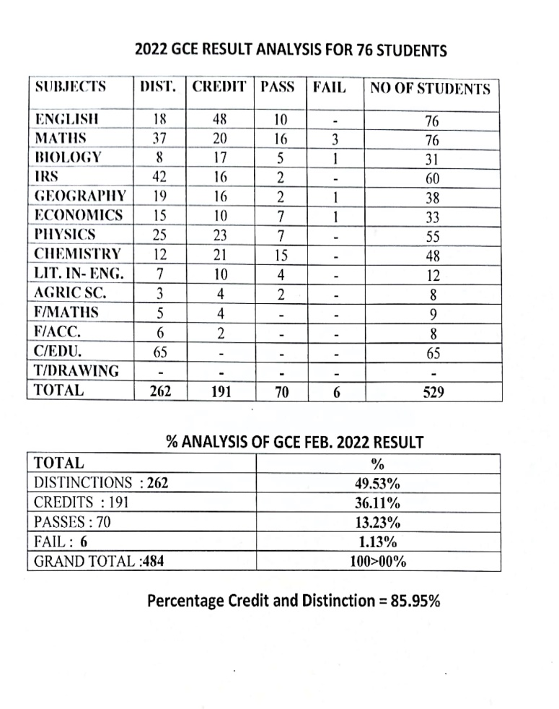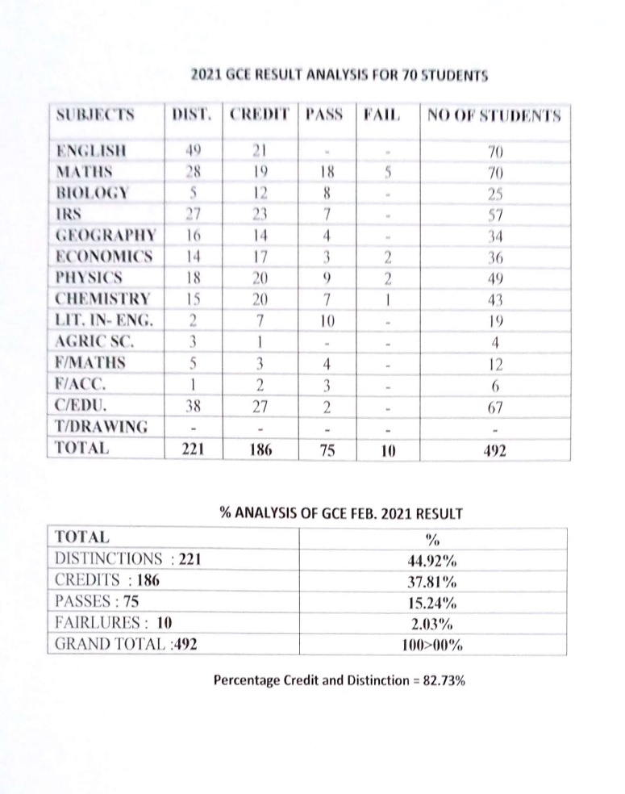

1. **PTA Exco Security Levy**

Following the discussion during the last PTA General Meeting about the current security situation in the country and steps the school is taking to ensure the protection of its students, the PTA Exco has followed up the recommendation of some parents during the meeting, which was to assist the school in reducing the financial burden of monthly payment made to security bodies.

The PTA Exco has directed the school to implement a security levy which parents are to pay per child/per term as follows:

* Parents of Boarders are to pay N5000 per child/per term
* Parents of Day students are to pay N2500 per child/per term

This fund will in sha Allah be used to either add additional Civil Defence personnel to those already on ground or employ the services of vigilantes and equip them. The school has been currently paying N380,000 monthly for 4 armed civil defence personnel it has on ground; this is aside other security expenses it has incurred over time.

1. **Ban on Visiting Day provision and food into the hostels**

After the first visiting day this term in February, there was an unprecedented amount of waste both on the visiting grounds and within the hotels. In addition, students were given three days after the visiting to consume the items the school had allowed them take into the hostel. This was based on the condition that after three days a raid will be conducted, and whatever items are still left remaining will be seized and sent as charity to the orphanage.

The norm has been for students to willingly come forward with the excess and donate it to be sent to the orphanage by Tuesday morning after each visiting. Usually, on Tuesday evenings we then conduct the raid to ensure there has been full compliance. Unfortunately, when the raid was conducted on Thursday in the Girls hostel and Friday in the Boys hostel (meaning they were given two-three extra days), we found an unprecedented amount of provisions in various hiding places within and outside the hostels; some were found in flowerbeds, water closet in toilets, overhead tanks, etc. We also found rotten chicken, fish and food!

Following the above discovery, a management meeting was held to discuss the way forward. Before coming to the decision to completely ban taking visiting day items into the hotel, the possibility of permitting regulated amount into the hostel was discussed but discarded due to the administrative nightmare it will create of checking each student for a ‘regulated amount’ he or she is taking into the hostel.

Lastly, before the incident, we had repeatedly counseled students on not wasting food, sharing food they cannot finish, etc., hence the stance we now have taken.

1. **Checking 2nd Term Exam and Behavioural Reports Online**

Alhamdullah for a successful navigation of another term. In sha Allah, parents will be able to check both their child’s Examination and Behavioural reports by Friday 15th April, 2022. To do so, parents are to use this link: <https://nhcminna.org/resultchecker> . Once clicked, a result checker will open where parents are to input their child’s admission number, which will then reveal a drop-down menu with three options provided. This includes: report sheet, students behavioural report and pocket money report.

1. **Resumption date/time for 3rd term**

In sha Allah the school will resume on Saturday 7th May, 2022, on or before 5pm.

We ask Allah to protect our children during the holiday and bring them safely back to school after Ramadan.

Parents are hereby reminded that they are required to call ahead and notify the school if any situation develops which stops or will stop them from returning their child/children on time. We wish you Eid Mubarak in advance.

Wassalamu alaykum wa rahmatullah wa barakatuh.

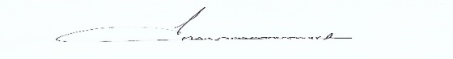

Mustafa Mas’ood

**Principal**